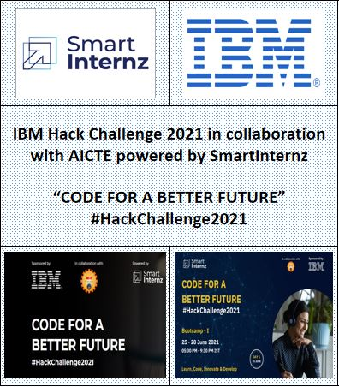

**Fashion Redefined with Virtual Grooming & Shopping Assistant**

**STUDENT DESIGN PROJECT REPORT**

*Submitted by*

***RISHII KP***

***KALLISH KUMAR N***

***SAGAYASREE Z***

***SUSHANTH ARUNACHALAM***

**Bachelor of Engineering**

**In**

**Computer Science and Engineering**

**RAJALAKSHMI INSTITUTE OF TECHNOLOGY**

 

**IBM HACK CHALLENGE 2021**

**BONAFIDE CERTIFICATE**

Certified that this project report **“Fashion Redefined with Virtual Grooming & Shopping Assistant”** is the bonafide work of **“RISHII KP, KALLISH KUMAR N, SAGAYASREE Z, SUSHANTH ARUNACHALAM”** who carried out the project work under my supervision.

# **Dr.R.Lalitha Tulasi, Hemant kumar Gahlot**

**SUPERVISOR,** **SUPERVISOR**

Professor, Smartbridge Educational,

Dept. Of Computer Science and Engg., Services Private Limited.

Rajalakshmi Institute of Technology, Plot No 132, Bapuji Nagar,

Kuthambakkam Post, National Highway 4, Habsiguda,Above DCB bank,

Chembarambakkam, 2nd floor,Nacharam Main

Chennai, Tamil Nadu 600124 Road,Hyderabad – 500 076

**TABLE OF CONTENTS**

**CHAPTER NO. TITLE PAGE NO.**

1 **INTRODUCTION** 1

1.1 Overview 1

1.2 Purpose 2

2 **LITERATURE SURVEY**  3

2.1 Existing Solution 3

2.2 Proposed Solution 4

3 **THEORETICAL ANALYSIS**  5

3.1 Block Diagram 5

3.2 Hardware/Software Designing 6

4 **EXPERIMENTAL INVESTIGATIONS**  12

5 **RESULT**  13

6 **ADVANTAGES AND DISADVANTAGES**  18

7 **APPLICATIONS**  19

8 **CONCLUSION AND FUTURE SCOPE**  20

9 **REFERENCES**  21

**APPENDIX**  22

1. Source Code 22

**CHAPTER 1**

**INTRODUCTION**

In this modern world, everyone wants to be dressed up in a way that reflects ‘Attraction’. Evidently, nature decides how a person has to be, not clothes. But at the same time, there is no rejection in raising one’s fashion standard. Fashion has the ability to change and shape lives through its personal connection. Fashion brands are also keeping up to speed and implementing online shopping platforms in addition to their traditional offline stores.Most retailers develop mobile applications to make online shopping increasingly easier and quicker for their customers. At the same time, with online shopping people are losing approach, that is “personal touch”. Many people are used to experiencing in ordinary brick-and-mortar shops. This is especially felt in fashion shopping .when they are shopping for clothes, especially brand name clothes, they want to feel special, they want a trial and catered for, or else they leave the store looking for best. Unfortunately, with all the ease and convenience of online shopping, a shopping cart cannot say that “this dress looks awesome like it was made especially for them“. Fashion brands are now adopting new technologies such as artificial intelligence, deep learning, ar/vr in particular, to recreate that personalized atmosphere of a beauty boutique right within their online applications and websites. To overcome this complication ,a chatbot in ecommerce can supply that missing loop between the customer and the retailer creating a personalized approach to each user while keeping the convenience of online shopping.

* 1. **Overview**

In order to make online shopping interactive, the proposed system is designed in such a way that it provides suggestions to the users. The chatbot engages in a realistic conversation ,first it introduces itself as a chatbot and then offering a variety of options. Users’ can browse the collection of items which they need and the chatbot will assist them in selecting an outfit. The bot filters the collections to suggest the items which fits according to users’ style. Chatbots are very helpful in providing answers to the questions from users’, however when asked a question which does not fit into the programmed pattern, the chatbots tends to become confused and either lead you with more questions or suggest transferring your chats to the respective organization, once rectified you will receive a mail. The proposed system is designed as an website where the chatbot will be available for users’ assistance. The proposed system also consists of virtual-try on feature with personalized fashion based suggestions feature based on particular users’ looks. The personalize fashion based feature accepts users’ image and analyzes and provides suggestions based on CNN model with suggestions given by chatbot. The virtual try-on feature provides an realistic shopping experience by accepting users’ image and it also accepts user’s cloth image or cloth image selected by the user from cloth list and finally it produces an realistic image by fitting the cloth on users’ image. This feature helps users’ in shopping clothes online based on their appearance.

* 1. **Purpose**

The purpose is to make online shopping more interactive, provide realistic experience and give personalized suggestions based on users’ looks. The proposed system interacts with users’ through chatbot. The chatbot helps in assisting users’ queries and provides suggestions based on their queries. The users’ can get personalized fashion suggestions based on their looks. The user can upload their image and based on their looks, related suggestions will be displayed to users’. To get an realistic virtual try-on experienec, users’ can upload their image and select an cloth image provided which in turn will produce an realistic image by fitting the cloth on users’ image. This gives insights to users’ whether to shop the cloth or not. By using this proposed system, users’ can get an interactive online shopping experience. It gives personalized suggestions based on users’ looks which might help user in knowing more about fashion trends. Moreover users’ can know about latest fashion trends through chatbot.

**CHAPTER 2**

**LITERATURE SURVEY**

There are various papers and proposed by authors based on fashion. Many new projects are being proposed in fashion by various researchers based on new technologies which keep evolving over a period of time. Moreover, all research based ideas common base is to provide customers an easy and comfortable shopping with their applications or websites. The keypoint here is that researchers keep the same base idea and they try to provide an enhanced version of previous idea. The enhancements made in projects or ideas directly depends on the trending technologies such as deep learning, artificial intelligence, augumented reality and virual reality etc. Each new research idea based on trending technology provides new insights and further this can be enhanced by upcoming latest technologies. According to fashion related domain, there are various projects, research based ideas proposed by authors, students and researchers.

**2.1 Existing Solution**

Soundarya. S. Jetty [1] have proposed an research idea by designing an shopping cart using augumented reality technology. Their design idea is to create an shopping cart application which uses filters for each categories such as caps, ornaments and cooling glasses where users can virtually try them and they can shop the product which suits them. They have used face detection algorithm to detect face and augumented reality technology to fit the products on user’s live input video. They have used andriod studio to design an application and to embed both face detection as well as the ar based filters inside the application.

Fuwei Zhao [2] have proposed an system which implements the features of both 2D and 3D. They have designed an 3D-Monocular Virtual try on network where the user will upload their image and will select cloth from clothlist, after uploading both images, an 3D realistic image will be generated with multiple poses of user’s image. They have used Monocular Prediction Module(MPM) along with Depth Refinement Module(DRM) and Texture Fusion Module (TFM) which implements Generative Adversarial Network model (GAN).

Szu-Ying Chen [3] have implemented an system which performs deep virtual try-on with clothes. They use Conditional Analogy Generativr Adversarial Network (CAGAN) which generates mask of input image and cloth image. Then the system performs segmentation on input image along with mask image. Input cloth is combined with mask image and transforms it as warped image. The user image and warped image are combined and produced as final image with selected cloth image.

Han Yang, Ruimao Zhang [4] have implemented an system which overcomes the challenge faced to generate realistic picture of virtual try-on. They have used Adaptive Content Generating and Preserving Network (ACGPN), this predicts semantic layout of reference image that wll change after try-on. They generate inference on the reference image and preprocess the image and test it on users’ image. This system generates photo-realistic images with better perceptual quality.

Ruiyun Yu [5] have proposed a system which implements VTNFP which is a virtual try-on network. It helps in synthesizing photo-realistic images by using cloth person image and target cloth image. It follows three-stage design methodology. First, it transforms the cloth person image into a warped form. Then it performs segmentation on the image by predicting the target cloth and as well as person image. The warped image along with segmentation map and person image are combined together which produces the try-on result.

Hideki Tsunashima [6] have proposed a system where they use Unsupervised Virtual Try-on using disentangled representation (UVIRT). They have compared with other virtual try-on papers and found that most of the ideas involved annotated data of images with weak supervised network. To overcome those drawbacks, they have used unsupervised network model. This model extracts the cloth and person feature from person image and cloth. The unsupervised model do not need any annotated data, pre-trained networks and category labels. They have conducted experiments on UVIRT model by testing both quantitatively and qualitatively which helps in comparing supervised methods and UVIRT method on MPV dataset which consists of paired images. The results states that UVIRT outperforms supervised methods on MPV dataset.

These are some of the existing system based on fashion related areas. Many reseearchers and project developers have used virtual try-on concept which is the base idea. Based on the emerging technologies over a period of time, many research projects and ideas have been developed by enhancing them and upgrading them to latest technologies.

**2.2 Proposed System**

The proposed system is used to provide fashion based suggestions based on users’ looks. It helps in assisting users with the help of chatbot which intrroduces itself to users’ and gives latest updates regardingfashion trends. It also helps in clearing user queries by providing suggestions to users. The system also has another suggestion which is based on CNN Model. The user will upload image and based on the image uploaded, cnn model will predict the type of image and will provide suggestions to user. This is implemented as an website where users can use this to know about fashion that suits them.

**CHAPTER 3**

**THEORETICAL ANALYSIS**

The overview of proposed solution has been explained in chapter 2. The detailed working of the proposed solution will be explained in this chapter with hardware and software involved in this system with block diagram.

**3.1 Block Diagram**

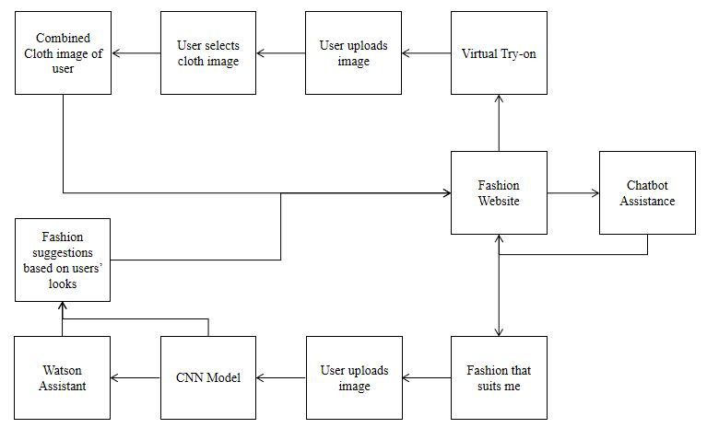

**Fig. 1 Block Diagram**

The block diagram of this system is explained in Fig.1. First, this system has an website which is called as fashion website. This website has three main features embedded in it. The first one is, fashion that suits me, second one is chatbot which gives recommendations to users’ queries and third one is virtual try-on feature. When an user visits fashion website, they can either use chatbot to ask their queries and the chatbot can provide suggestions based on user’s queries or they can directly click fashion that suits me feature. When they choose fashion that suits me option, the user is directed to fashion page where they can upload their image. After uploading the image, Cnn model is invoked and it helps in predicting the fashion class of image. When it predicts the class, it sends the predicted fashion class to watson assistant as well as to suggestions script. Here two processes are involved, one is the predicted fashion class is given as input to python script where it compares with fashion based conditions in the script, based on the predicted class and fashion condition, the script will give related images to that class along with other fashion products as suggestions to user. This gives users an insight about fashion based trends. It provides matching fashion based products related to the predicted fashion class as suggestions to users’. The other process is that, the prediced fashion class is passed as input to watson assistant. The assistant recognizes the intent related to the predicted fashion class and it provides fashion based suggestions with image of the fashion product and the link for the fashion product to users’. The user can click the link and can visit the website and shop the product.

The second feature is that when user visits fashion website, they can invoke watson assistant. When the assistant is invoked, the assistant introduces itself to users. It provides latest fashion related trends information to users. The user can type their queries to chatbot and chatbot can provide related suggestions to the query. The user can obtain fashion based suggestions from watson assistant also. When an user searches for a particular fashion product, the chatbot recognizes the fashion based intent related to that fashion product. Based on that intent, the queries which need to be asked to user are being asked by the assistant and based on the response given by the user, it provides fashion based recommendations with image of the product as well as the link to shop that product.

The Third feature is that an user can visit fashion website and directly navigate to virtual try-on. This navigates user to virtual try-on page. User has to upload their image and they can select an cloth image from the list of cloth images provided. After user selects cloth image and when they confirm, they get an an realistic virtual try-on image by fusing the cloth image over person image. The user can also upload their personal cloth image and person image to check whether the cloth suits them or not. This feature provides an relaistic virtual try-on experience for users’ . It provides insights to users’ whether to shop this cloth product or not.

**3.2 Hardware/Software Designing**

The proposed system uses CPU and GPU environments which involves hardware such as laptop, google colab, IBM cloud services.

The proposed system involves various softwares for implementing this system. It uses various services such as

* IBM Cloud Service
* IBM Watson Assistant Service
* IBM Watson Studio Service
* IBM Jupyter Notebook Service
* Python 3.7
* Anaconda Prompt
* Jupyter Notebook
* Spyder
* Flask Application
* Smartinternz website(Milestone Completion)

**Working of Proposed System:**

The Working of proposed system can be split into four parts

1. Building an CNN Model
2. Building an Chatbot using IBM Watson Assistant
3. Building an Virtual Try-On Model
4. Building an Flask based application
5. Deploy the CNN Model on IBM Cloud
6. **Building an CNN Model**

The first phase of the proposed system is to build an cnn model. To build a model, an dataset is required. Since the system is going to classify fashion related products, a fashion based dataset is chosen for cnn model. The fashion based dataset consists of around 44,000 plus images. The images were categorized into various fashion related categories such as Bag, Chappals, Sandals, Ornaments, Tops, pants, shirt, tshirt etc. After classifying, there were around 63 classes. These classes were split into train set and test set. The train set consists 80% of images and test set consists of 20% of images. The final fashion dataset for training cnn model has been made ready.

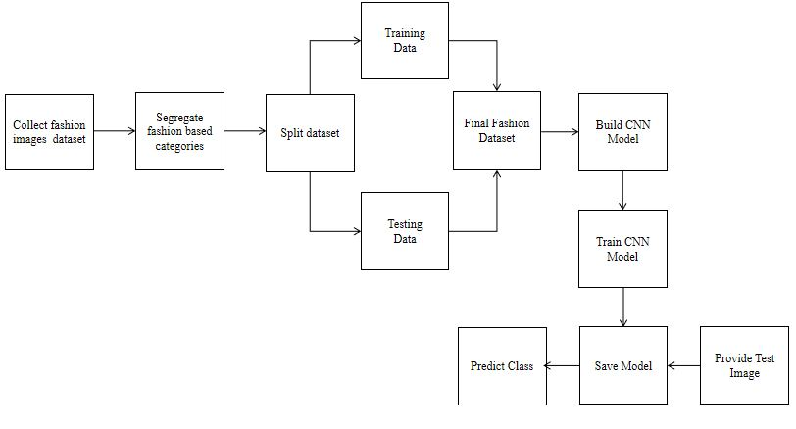

**Fig 2. Building CNN Model**

The CNN model is built using deep learning algorithm which is Convolutional Neural Network (CNN). To train this model, tensorflow 1.14.0 and keras 2.2.4 packages were needed. After installing the required packages, data generator for both test and train were generated with batch size 64 and class as categorical. The dataset is loaded for both train and test set. Then initialize sequential models and add pooling layer with flatten layer and initialize number of units along with number\_of\_epochs and steps\_per epochs for fitting the model and training and testing the model. After training the model, save the h5 model. Then provide test image to test the model and the model provides the predicted class as output.

1. **Building an chatbot using Ibm watson assistant**

To provide fashion based suggestions and recommendations, an chatbot is being designed using IBM watson assistant service. First, create an IBM cloud account. Then create watson assistant service and launch the watson assistant. After launching, create an new assistant named Fashion Chatbot. Create a new skill for the chatbot. Create various fashion based intents with examples such as Male formals shirt, male formals pants, Male Tshirts, Female Kurtis, Female legins etc. Create dialog nodes and align them based on the fashion based categories. Create conditions where the chatbot has to ask queries to the user based on the intent which the assistant recognizes such as when the assistant recognizes ‘Male formal Shirt’, it asks for the color of the shirt and provides recommendations. When user asks for a formal shirt, the chatbot asks the gender of user and type of formal shirt they need and the color of the formal shirt and then it provides suggestions. Inside each fashion based category, provide an fashion product image along with its shopping link. Preview the assistant to check if it is working as expected. If any changes, then modify the dialogue nodes and conditions to meet the expected results.

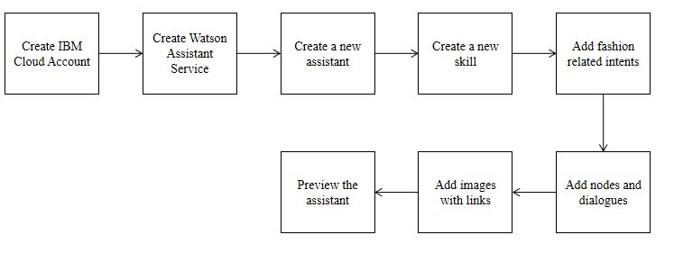

**Fig 3. Building an chatbot using Ibm Watson Assistant**

1. **Building an Virtual Try-On Model**

The Virtual try-on model provides an realistic virtual try-on experience for users. This model is created by geometric measurement model gmm and try on module. The Virtual Try on Dataset consists of train and test folders with cloth images, warped images , mask images in both train and test folders with train and test pairs of images. The model is trained on gmm and tom and final checkpoints are downloaded for testing the model’s prediction. In order to test this in website, the system builds an flask application to implement this virtual try-on feature. Create an html template for displaying cloth images and to upload user image and cloth image. Create css and js scripts to get the output from python script and display them in website. Put html file in templates folder and js, css files in static folder. Create Checkpoints folder and store the pretrained checkpoints. Install the dependency packages required to run this flask application. Create python script app.py to load the checkpints and to perform virtual try-on network on user image and cloth image and to produce the realistic virtual try-on image. Deploy the flask application on localhost using anaconda prompt. This virtual try-on feature provides insights to users’ whether to select particular product or not. They can also upload their individual cloth image and can find out whether the product matches them or not. When the flask application is deployed, the user visits fashion website and when they select virtual try-on, they are navigated to virtual try-on page. They upload their image and either can choose cloth image from cloth list or they can upload personal cloth image to check the virtual try-on result.

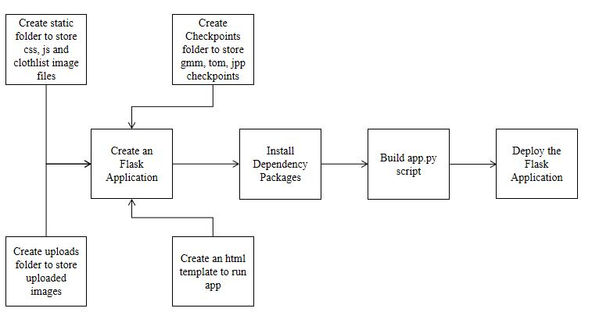

**Fig 4.** **Building an Virtual Try-On Model**

1. **Building an Flask based application**

The fashion website is built using flask application. The Chatbot, CNN Model and virtual try-on features are integrated with this flask app. Create fashion website html page and store related html templates in templates folder. Create js, bootstrap and css files to provide animations, style to fashion website. Store them in static folder. Install the dependency packages required to run this flask application. Build app.py script to perform chatbot suggestions, fashion based suggestions and virtual try-on results. Finally deploy the flask application in localhost using anaconda prompt

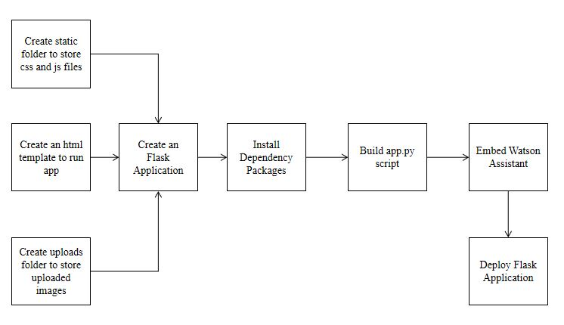

**Fig 4.** **Building a Flask based Application**

1. **Deploying the CNN Model on IBM Cloud**

After building the CNN Model, the model has to be deployed in an deployment space. To deploy the model, the proposed system uses IBM Cloud service and IBM Machine learning service. After saving the model, the machine learning service credentials are obtained by creating a new api key. Then launch watson studio and navigate to deployments and create a new space. Once new space is created, navigate to notebook and initialize the tar file to be downloaded with the model. After initializing, get space id and model id of the user space. Download the model with tensorflow version-1.5.0py3.6. Get the model id. Save the model to the newly created space. Once saved, the model appears in the assests tab of that space. Open localhost and type jupyter notebook, initialize the same machine learning credentials and get the user space id and initialize the tar file to be downloaded with tensorflow version 1.15py3.6. Get the model\_id and download the tar file. Extract the model to downloads and then the model can be used in local system.

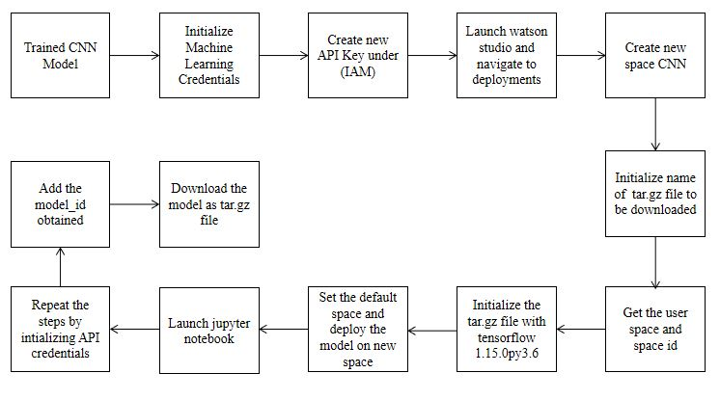

**Fig 5.** **Deploying CNN Model on IBM Cloud**

**CHAPTER 4**

**EXPERIMENTAL INVESTIGATIONS**

The proposed system consists of CNN model which has been trained with accuracy of 80% and a test accuracy of 79.56%. The model is deployed into flask application. This model predicts the class of the image provided and gives the predicted class. Based on the predicted class, the conditions in app.py script will be evaluated and most relevant condition will be chosen and will give matching fashion based products related to the uploaded image. The user can understand that these are the matcing pairs for the respective fashion product. Also the predicted class is passed as input to the watson assistant and there the assistant recognizes the intent related to that predicted class. It provides related suggestions to that fashion product by providing fashion product image along with shopping link of that product. The Virtual try-on accepts two images namely person image and cloth image as input, then it provides a combined image of cloth and person image which gives realistic virtual try-on experience to user. All these features are deployed in flask application where it will be hosted into localhost website. This website will load the html template and the html page will direct user to suggestions page and virtual try-on page. The home page will have a chatbot which is made using IBM watson assistant. This chatbot will help users to get fashion based recommendations and they can also clear their doubts regarding fashion based trends. The fashion that suits me page is the suggestions page will have an upload image button along with upload image button. When the user uploads image , the imge is sent as input to cnn model where it will return predicted class to suggestion page as well as watson assistant. At a time, suggestions will be displayed. Based on cnn model, matching fashion products suggestions related to predicted class will be displayed and assistant will also return fashion products images with shopping links related to that image. The virtual try-on button will navigate user to virtual try-on page where there will be upload image button, with list of cloth image to try virtual try-on and another button for the user to upload personal cloth image. The user will upload image and select an image from cloth list, after giving confirm, the virtual try-on result will be displayed with uploaded image as output. These are some of the experimental investigations of proposed system.

**CHAPTER 5**

**RESULTS**

**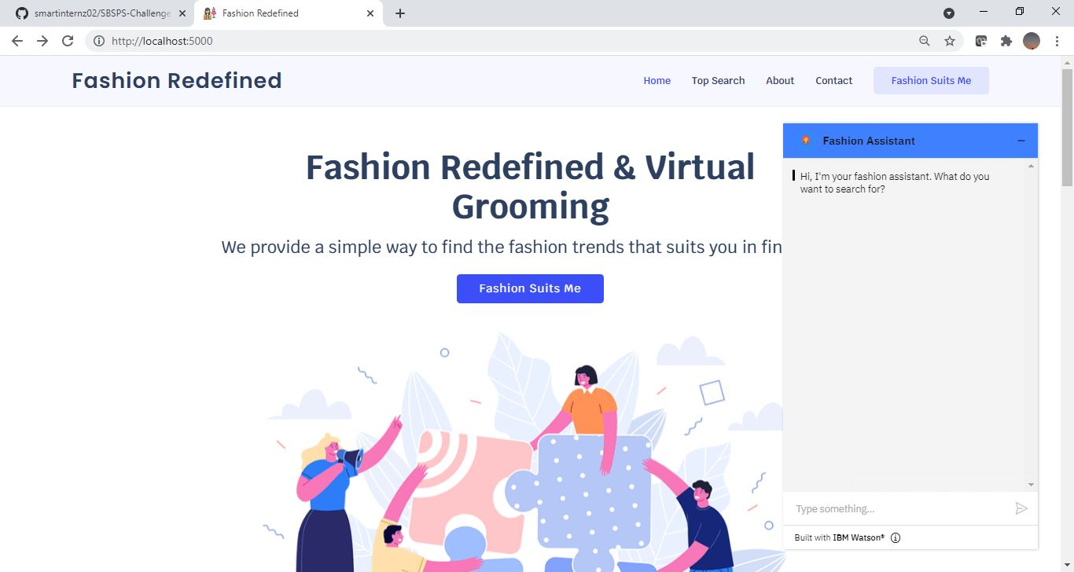**

**Fig. 6 Fashion Redefined Home Page**

**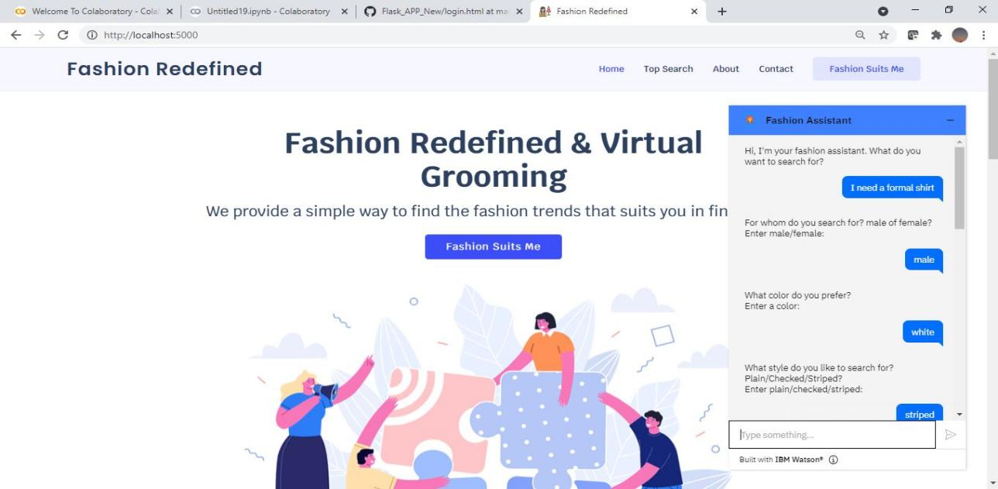**

**Fig. 7 Chatbot Suggestions**

**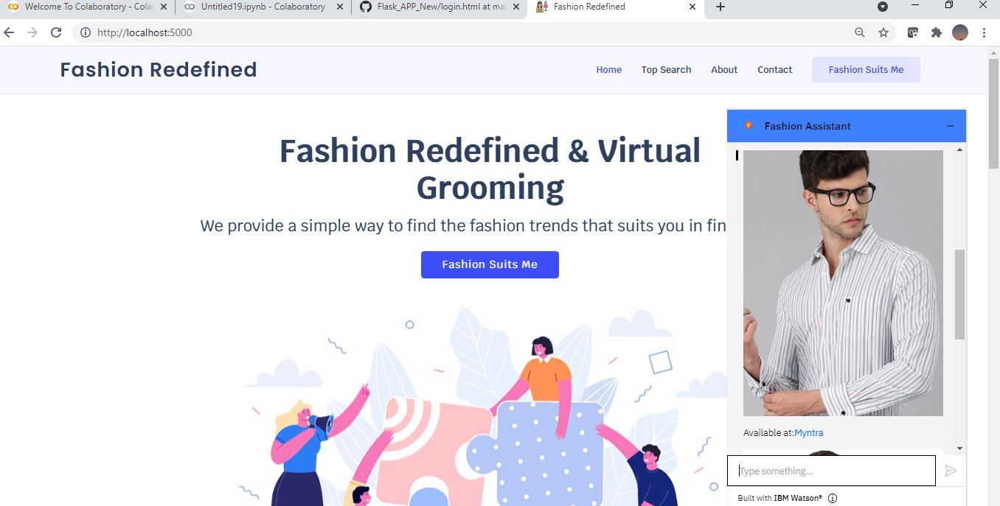**

**Fig. 8 Chatbot Suggestions**

**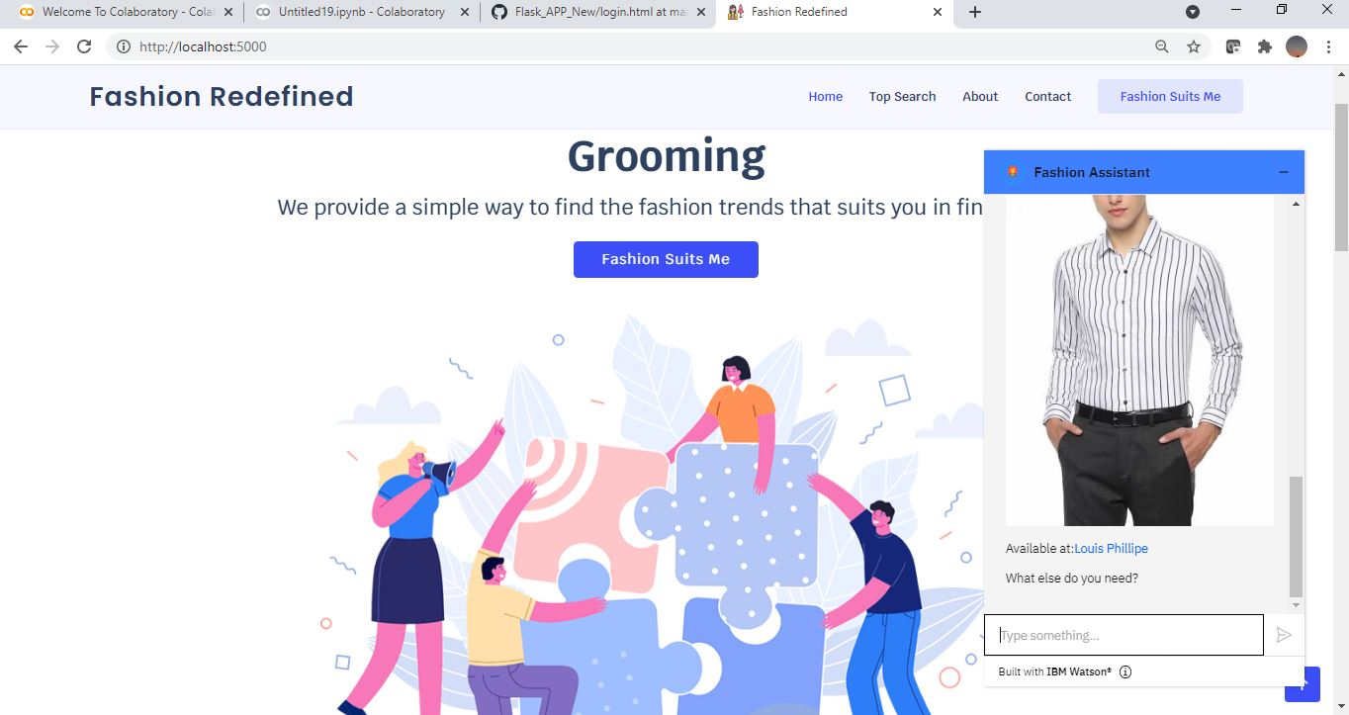**

**Fig. 9 Chatbot Suggestions**

**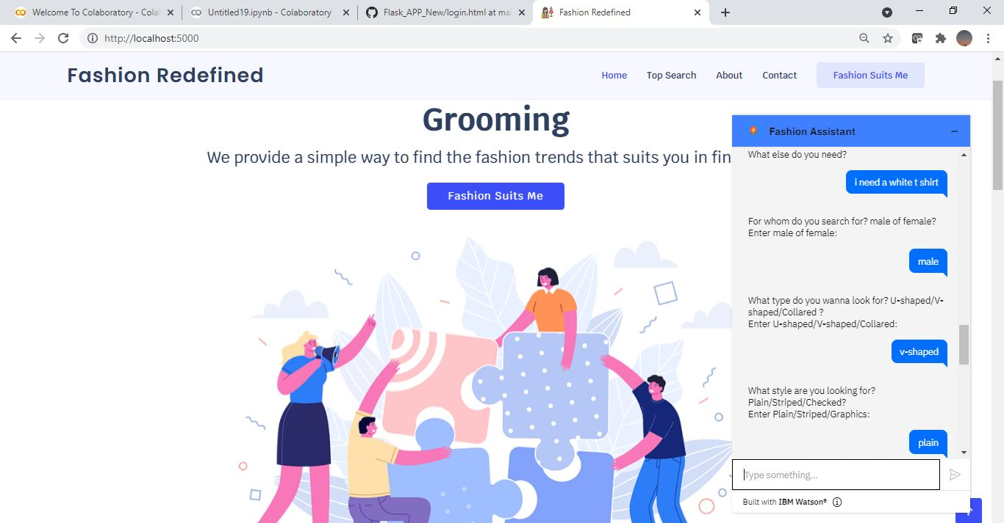**

**Fig. 10 Chatbot Suggestions**

**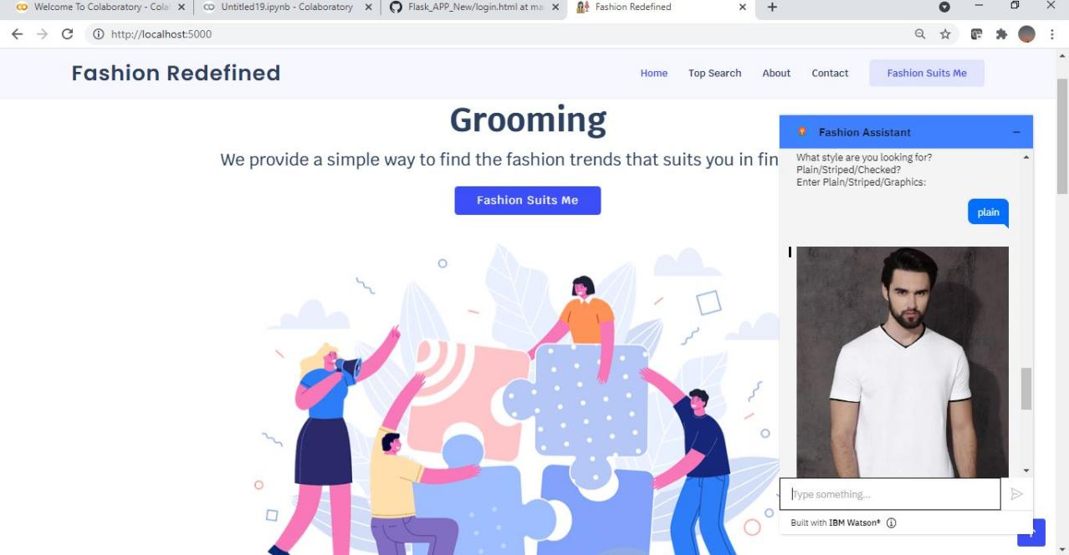**

**Fig. 11 Chatbot Suggestions**

**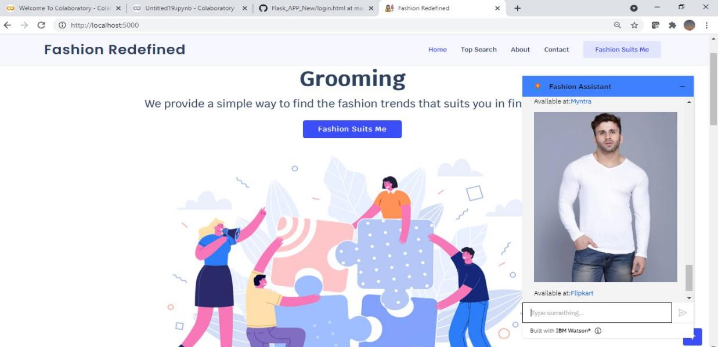**

**Fig. 12 Chatbot Suggestions**

**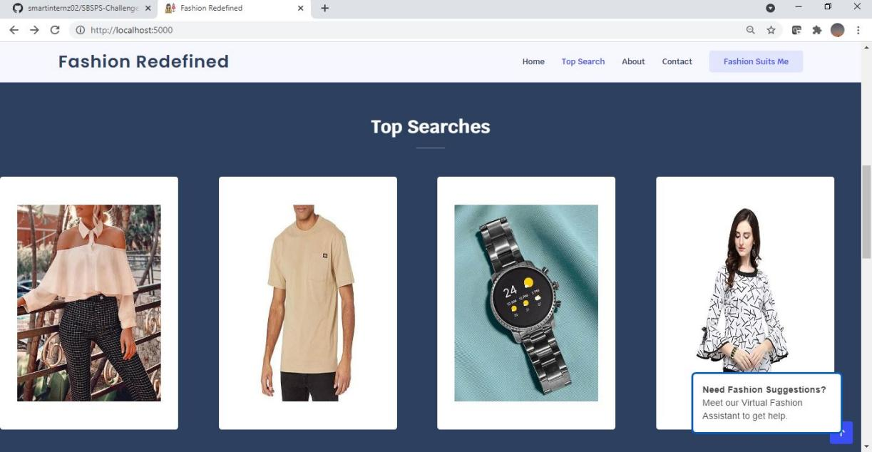**

**Fig. 13 Top Searches Section**

**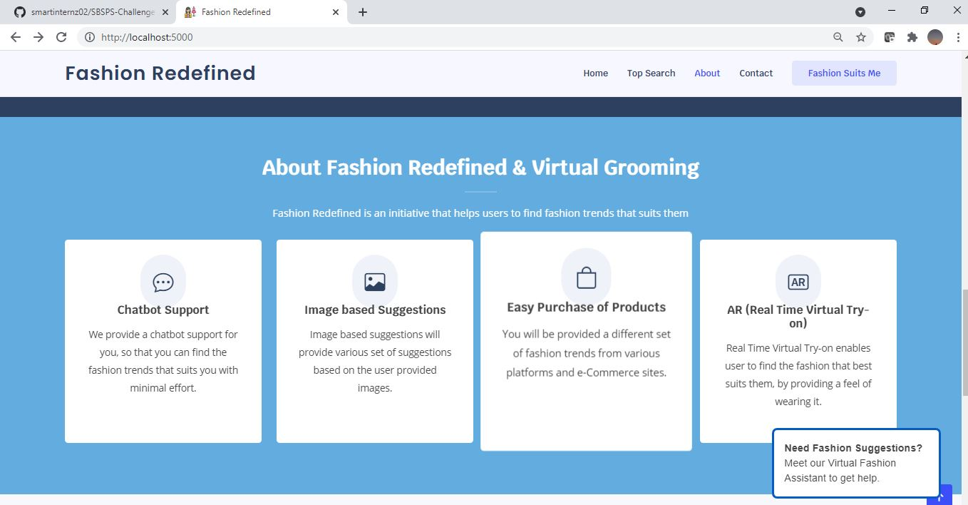**

**Fig. 13 About Section**

**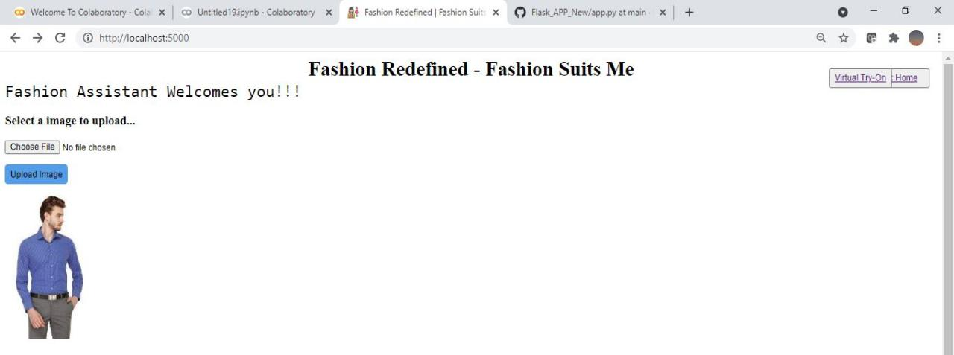**

**Fig. 14 Suggestions Page**

**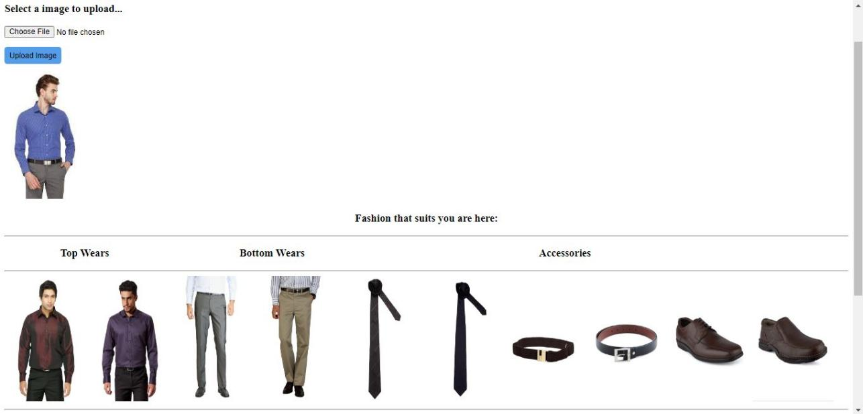**

**Fig. 15 Matching Fashion Products**

**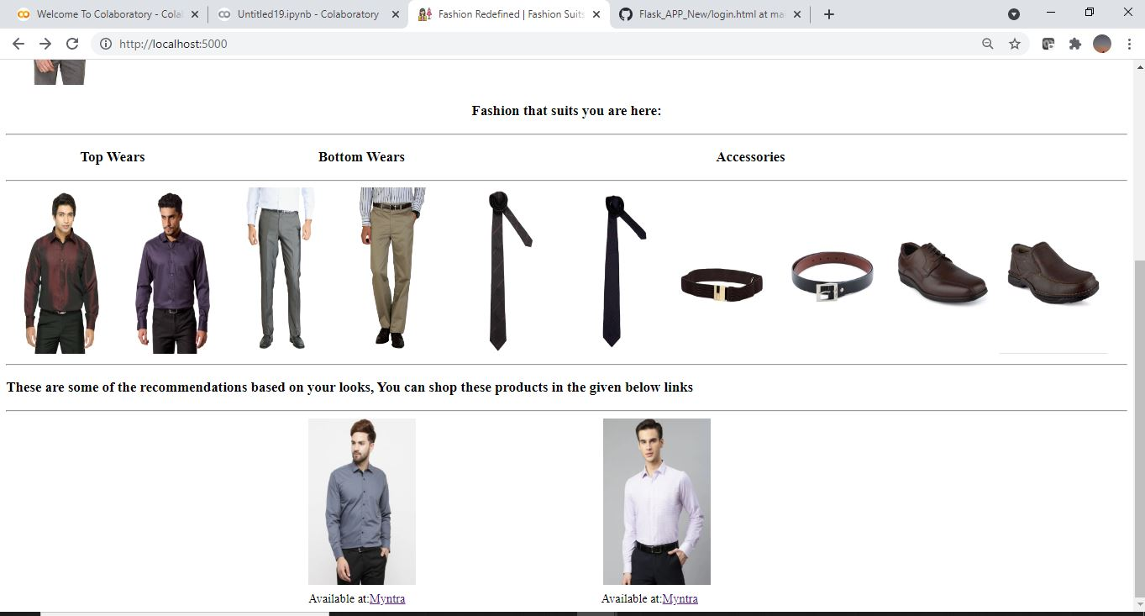**

**Fig. 16 Recommendation Links**

**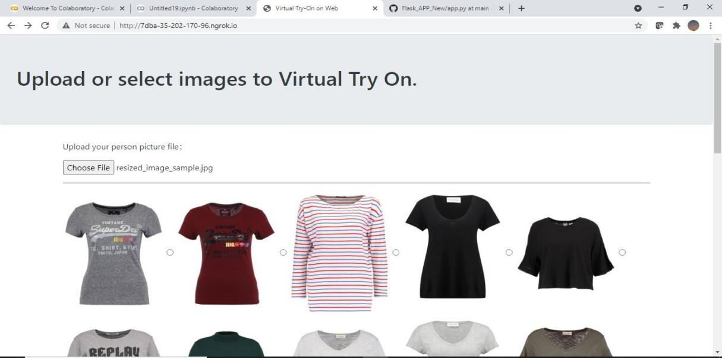**

**Fig. 17 Virtual\_tryon\_page**

**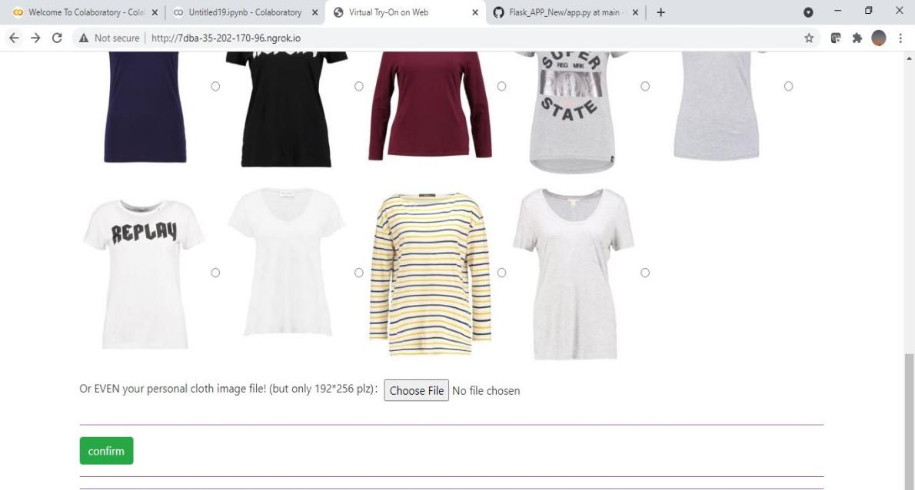**

**Fig 18. Confirm Section**

**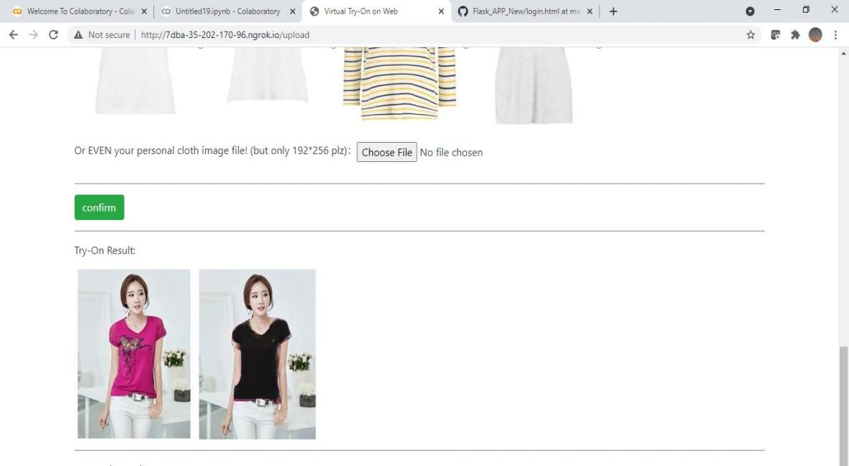**

**Fig. 19 Try-on Result**

**CHAPTER 6**

**ADVANTAGES AND DISADVANTAGES**

* It enables users to find costume based on their interest that also best suits their looks.
* It allows users to check how the costumes of their wish which fits them by using Virtual Try-on feature.
* It provides various set of matching fashion suggestions from different e-Commerce websites / applications along with their shopping links to purchase them.
* Chatbot’s suggestions also contain shopping links that will be useful for users to purchase their fashion products.
* It provides a complete fashion based try-on fetaures for individuals who aren’t aware of fashion trends and also for fashion geeks.

**Disadvantages**

* The model’s prediction rate is an critical factor
* Need large dataset for training the model

**CHAPTER 7**

**APPLICATIONS**

* A modern technology that enables user to find their best fit costumes for respective occasions.
* It can be merged with popular E-Commerce website/application to provide appropriate suggestions that also best suits them.
* This application can be used in all fashion based shops, malls etc.
* This application can be used to promote online shopping with virtual try-on feature.

**CHAPTER 8**

**CONCLUSION AND FUTURE ENHANCEMENT**

The proposed system helps users’ by assisting them through chatbot. It also provides matching fashion based suggestions based on the looks of the user. It provides fashion products images with shopping links to users so that they can shop that product using that link. The system also helps users in providing an realistic virtual-try on feature so that user can decide which product to buy and also they can even check with their own product image whether the product suits them or not. This proposed system acts as an complete fashion package which helps users to gain insights about fashion based trends which suits them and helps them in clearing queries of users by providing recommendations and information related to fashion based trends. Thus this application will help users in a realistic way.

**Future Enhancement**

* The proposed system can further be enhanced by using efficient virtual try-on algorithms.
* The system can use advanced cnn model to detect multiple classes and provide suggestions accordingly.
* To enhance the chatbot to interact with customers in realistic way
* To design virtual try-on filters using advanced technologies like augumented reality and virtual reality.

**CHAPTER 9**

**REFERENCES**

1. Soundarya. S. Jetty, Akshatha. R. P, Pooja. C, Mamatha. M, Nagaraj. A "Fashion Android Application using Augmented Reality" International Journal of Engineering Research & Technology (IJERT), Vol. 9 ,Issue 07, Jul. 2020.
2. Fuwei Zhao, Zhenyu Xie, Michael Kampffmeyer, Haoye Dong, Songfang Han, Tianxiang Zheng, Tao Zhang, Xiaodan Liang "M3D-VTON: A Monocular-to-3D Virtual Try-On Network" 2021 Cornell University. https://arxiv.org/abs/2108.05126.
3. Szu-Ying Chen, Kin-Wa Tsoi, Yung-Yu Chuang "Deep Virtual Try-on with Clothes Transform" 2019 International Computer Symposium(ICS) New Trends in Computer Technologies and Applications pp 207-214, Jul. 2019.
4. Han Yang, Ruimao Zhang, Xiaobao Guo, Wei Liu, Wangmeng Zuo, Ping Luo "Towards Photo-Realistic Virtual Try-On by Adaptively Generating Preserving Image Content" Mar 2020 Cornell University.https://arxiv.org/abs/2003.05863
5. Ruiyun Yu, Xiaoqi Wang, Xiaohui Xie "VTNFP: An Image-based Virtual Try-on Network with Body and Clothing Feature Preservation"IEEE Explore 2019 pp 10511-10520.
6. Hideki Tsunashima, Kosuke Arase, Antony Lam and Hirokatsu Kataoka "UVIRT—Unsupervised Virtual Try-on Using Disentangled Clothing and Person Features" Computer Vision Research Team, Artificial Intelligence Research Center, National Institute of Advanced Industrial Science and Technology (AIST), Oct. 2020.
7. <https://github.com/GrayXu/Virtual-Try-On-Flask>
8. <https://github.com/b01902041/Deep-Virtual-Try-on-with-Clothes-Transform>
9. [https://youtu.be/hS\_XQgI69kE](https://youtu.be/hS_XQgI69kE" \t "https://mail.google.com/mail/u/0/" \l "search/kallishkumar.n.2017.cse%40ritchennai.edu.in/_blank)
10. [https://youtu.be/sYdoLNQOzsk](https://youtu.be/sYdoLNQOzsk" \t "https://mail.google.com/mail/u/0/" \l "search/kallishkumar.n.2017.cse%40ritchennai.edu.in/_blank)
11. [https://youtu.be/6QNNIIJpaXw](https://youtu.be/6QNNIIJpaXw" \t "https://mail.google.com/mail/u/0/" \l "search/kallishkumar.n.2017.cse%40ritchennai.edu.in/_blank)
12. [https://github.com/trandinhson3086/cp-vton](https://github.com/trandinhson3086/cp-vton" \t "https://mail.google.com/mail/u/0/" \l "search/kallishkumar.n.2017.cse%40ritchennai.edu.in/_blank)
13. [https://youtu.be/A4Ee2K2tx68](https://youtu.be/A4Ee2K2tx68" \t "https://mail.google.com/mail/u/0/" \l "search/kallishkumar.n.2017.cse%40ritchennai.edu.in/_blank)

**APPENDIX**

**SOURCE CODE**

import numpy as np

import os

import random

import json

import urllib.request

from flask import Flask, flash, request, redirect, url\_for, render\_template, send\_from\_directory

from tensorflow.keras.preprocessing import image

from PIL import Image

import cv2

import base64

from datetime import datetime

from Model import Model

from io import StringIO, BytesIO

from tensorflow.keras.models import load\_model

from flask import Flask , request, render\_template

from werkzeug.utils import secure\_filename

from gevent.pywsgi import WSGIServer

from ibm\_watson import AssistantV2

from ibm\_cloud\_sdk\_core.authenticators import IAMAuthenticator

import time

#from flask\_ngrok import run\_with\_ngrok

app = Flask(\_\_name\_\_)

#run\_with\_ngrok(app)

model = load\_model("IBM\_Fashion\_Prediction\_Model.h5")

UPLOAD\_FOLDER = 'static/uploads/'

global filepath

app.config['UPLOAD\_FOLDER'] = UPLOAD\_FOLDER

app.config['MAX\_CONTENT\_LENGTH'] = 16 \* 1024 \* 1024

authenticator = IAMAuthenticator('R8mM6G5I5MZFow1V2LOMWcUsE0PsgyQzZhuJqT7fmsZG')

assistant = AssistantV2(

version='2021-06-14',

authenticator = authenticator

)

assistant.set\_service\_url('https://api.eu-gb.assistant.watson.cloud.ibm.com')

response = assistant.create\_session(

assistant\_id='f7f44aae-54ba-48c8-b400-58bd612f5f75'

).get\_result()

session\_id = response

session\_id = session\_id["session\_id"]

time.sleep(2.4)

@app.route('/', methods=['POST'])

def upload\_image():

file = request.files['file']

basepath = os.path.dirname(\_\_file\_\_)

print("current path", basepath)

filepath = os.path.join(basepath,'uploads',file.filename)

print("upload folder is ", filepath)

file.save(os.path.join(app.config['UPLOAD\_FOLDER'], file.filename))

print(file.filename)

filepath = os.path.join(app.config['UPLOAD\_FOLDER'], file.filename)

print(filepath)

img = image.load\_img(filepath,target\_size = (64,64))

x = image.img\_to\_array(img)

print(x)

x = np.expand\_dims(x,axis =0)

print(x)

preds = model.predict\_classes(x)

print("prediction",preds)